**Staintondale, Ravenscar and District Show.**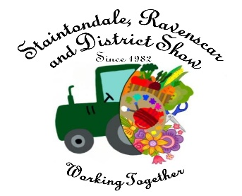

**10th August 2025.**

**Risk Assessment.**

|  |  |  |  |
| --- | --- | --- | --- |
| **Risk Assessment For:** | | **Risk Assessment Undertaken By:** | |
| **Company Name** |  | **Name** |  |
| **Address** |  | **Signature** |  |
| **Tel** |  |  |  |
| **Email** |  | **Date** |  |

|  |
| --- |
| **Description of Stand / Area /Facilities assessed** |
|  |

|  |
| --- |
| **Description of Activities Undertaken / Use** |
|  |

**Please identify any hazards that your stand/area/facilities may pose, including any fire risk, what is the level of risk? Please state who these risks may affect and what actions you will take to ensure that the risks identified have been removed or minimizes and are adequately controlled.**

|  |  |  |  |
| --- | --- | --- | --- |
| **Risk Identified** | **Level of Risk: Low, Medium, High** | **Who is at risk (e.g Visitors, employees)** | **Steps taken to control risk.** |
|  |  |  |  |
|  |  |  |  |
|  |  |  |  |
|  |  |  |  |
|  |  |  |  |
|  |  |  |  |
|  |  |  |  |

|  |
| --- |
| **Any additional information you feel may be relevant** |
|  |

|  |
| --- |
| **Details of responsible key contact on show day:** |
| **Name:**  **Contact No on Show Day:** |